# **How to create ec2 instance & security group using terraform**

* Firstly, we need create one folder named “Terraform” in ur local system after open your vs code and open your terraform folder which you have created in your local server.
* Inside the terraform folder you need to create a file named “provider.tf” as shown below image.

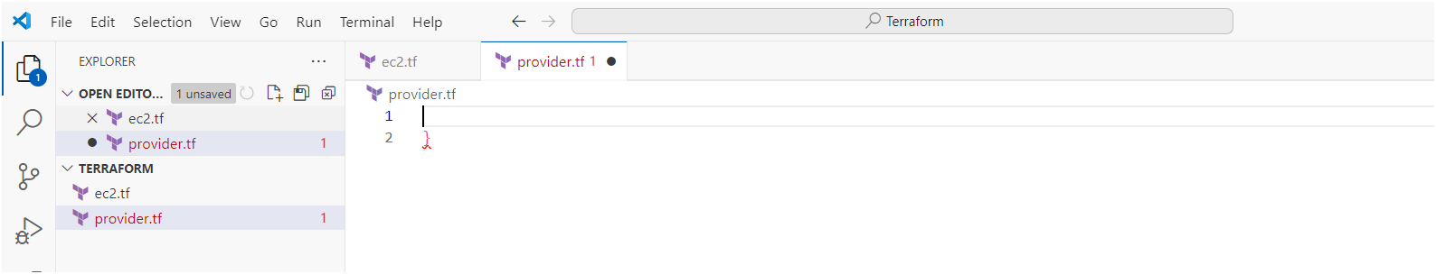

* Add below code to provider.tf file

terraform {

  required_providers {

    aws = {

      source  = "hashicorp/aws"

      version = "~> 5.0"

    }

  }

}

# Configure the AWS Provider

provider "aws" {

  region = "ap-south-1" # Go with your region

}

* Create ec2.tf file and paste below code 👇

resource "aws_instance" "web" {

  ami           = "ami-0ad21ae1d0696ad58" # Update with ami id

  instance_type = "t2.micro"

  key_name      = "dock"

  vpc_security_group_ids = [aws_security_group.david-sg.id]

  tags = {

    Name = "david-king"

  }

}

resource "aws_security_group" "david-sg" {

  name        = "david-sg"

  description = "security groups using terraform"

  vpc_id      = "vpc-084eea0fba4aa03c1" # Update with your vpc id

  ingress {

    description      = "HTTPS"

    from_port        = 443

    to_port          = 443

    protocol         = "tcp"

    cidr_blocks      = ["0.0.0.0/0"]

    ipv6_cidr_blocks = ["::/0"]

  }

  ingress {

    description      = "HTTP"

    from_port        = 80

    to_port          = 80

    protocol         = "tcp"

    cidr_blocks      = ["0.0.0.0/0"]

    ipv6_cidr_blocks = ["::/0"]

  }

  ingress {

    description      = "ssh"

    from_port        = 22

    to_port          = 22

    protocol         = "tcp"

    cidr_blocks      = ["0.0.0.0/0"]

    ipv6_cidr_blocks = ["::/0"]

  }

  egress {

    from_port        = 0

    to_port          = 0

    protocol         = "tcp"

    cidr_blocks      = ["0.0.0.0/0"]

    ipv6_cidr_blocks = ["::/0"]

  }

  tags = {

    Name = "david-SG"

  }

}

* Now open terminal in your vs code and execute following terraform commands.

1. Terraform init

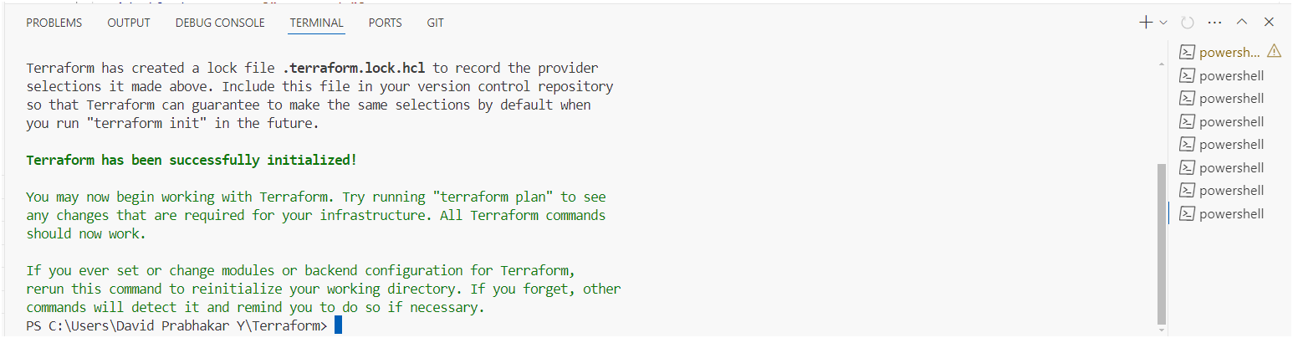

1. Terraform validate

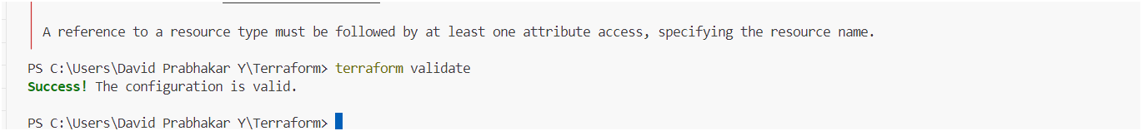

1. Terraform plan

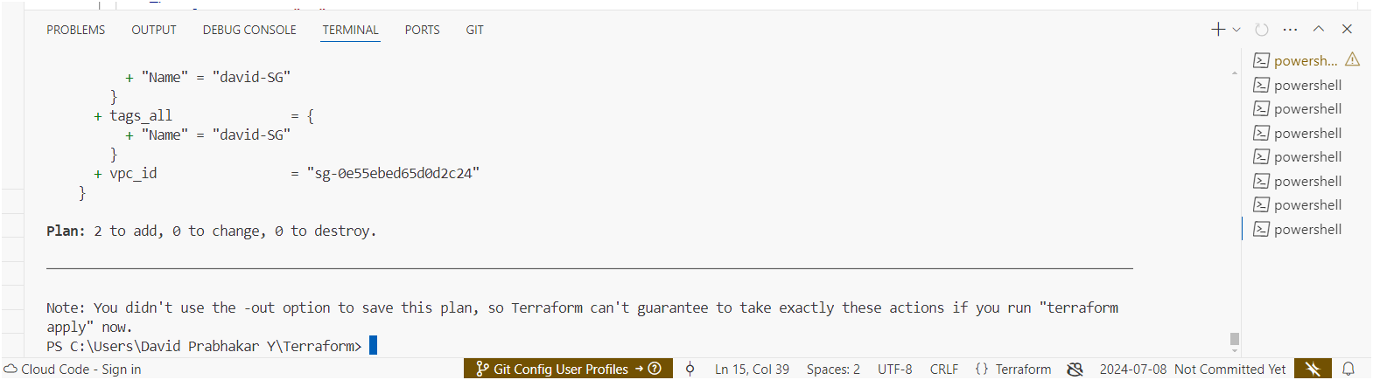

1. Terraform apply

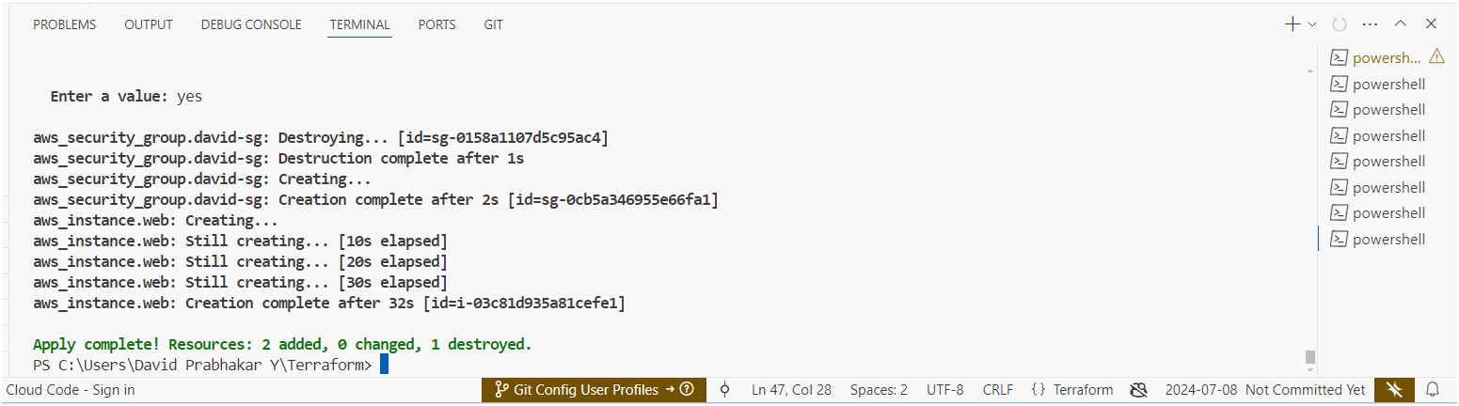

* Lets check our infrastructure is created or not
* Go to your aws account there you can check it.

**Ec2 instance**

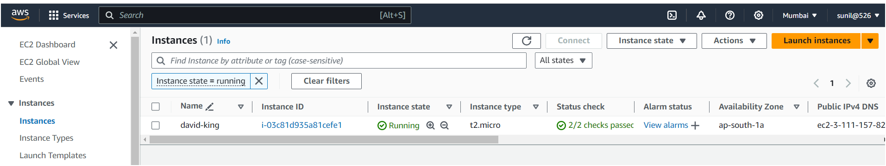

**Security group**

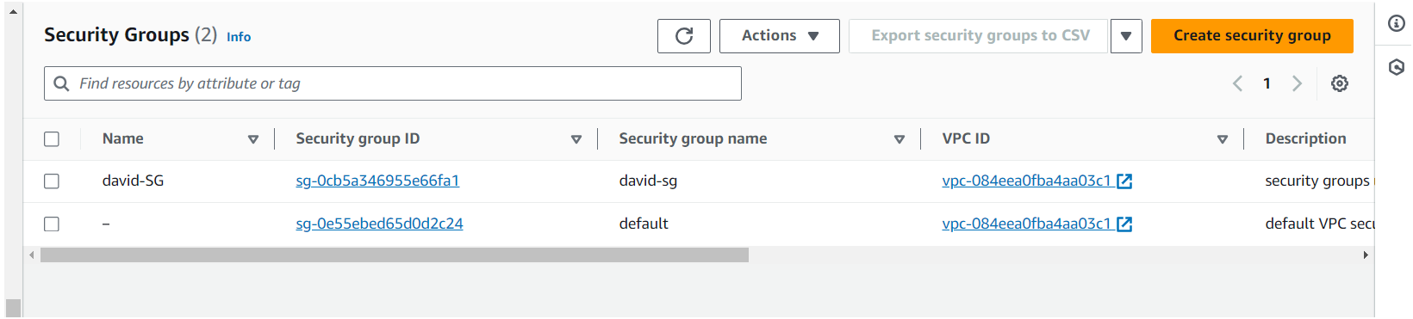

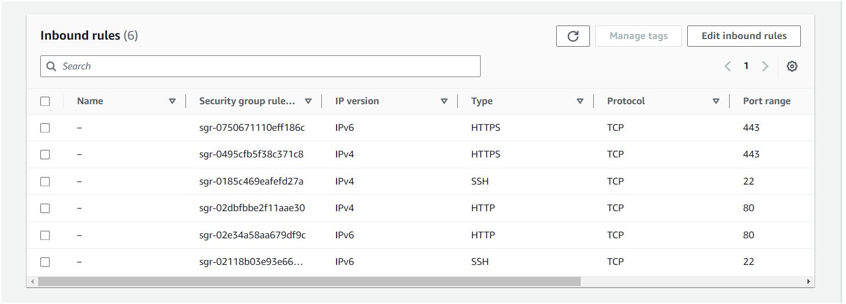

* Our infrastructure is created successfully as we seen above images.
* Now we need to destroy all the resources which we have created.

1. Terraform destroy

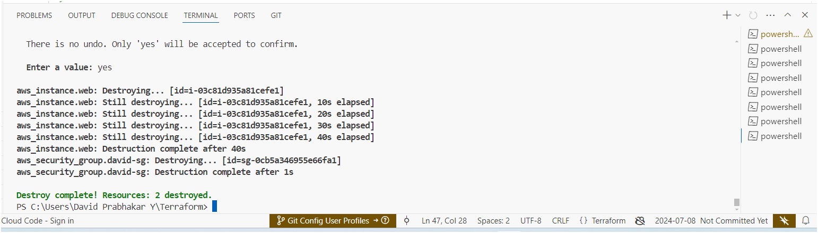

* Successfully destroyed all infrastructure as shown above image.
* Instance got terminates as shown below image

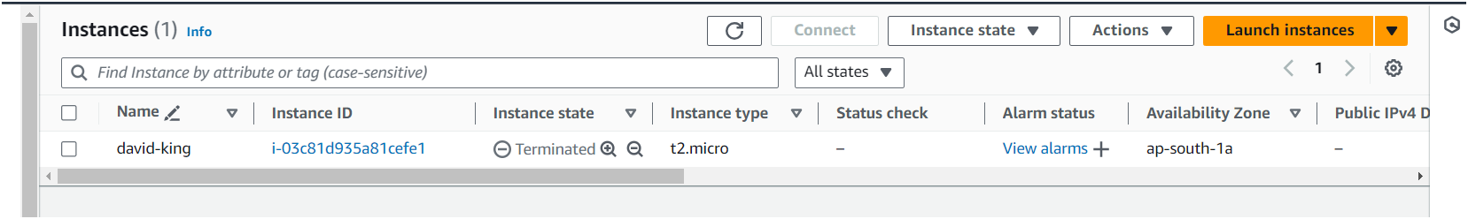

* Security group also got deleted as shown below image.

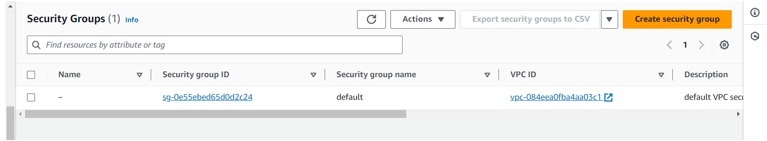

**THE END**